| **Report on Information and****Communication Technologies (TIC)** |
| --- |

### 

### 

### 

| **Group members:****Sadeddine Nour Said****Zohair Benmakhloufi****Mokadem Abderaouf****Bachi Nassim****Youb Oussama** |
| --- |

### 

### 

### **Table of Contents:**

* 1 Introduction into Tic
  + 1.1 Definition of Tic
  + 1.2 The Objective and Goal of Tic
* 2 History and Economy of Tic
  + 2.1 The Development History of Tic
  + 2.2 The Economics of Tic
* 3 Tic as a subject in Education
  + 3.1 In developed countries
  + 3.2 In developing (3rd world) countries
* **4 The Tech Giants and Important Technologies in TIC:**
  + 4.1 The Tech Giants
  + 4.2 Important inventions
* 5 Modern day Challenges Associated with TIC
* 6 Modern day Applications of Tic
* 7 Conclusion
* 8 Sources

## **1 Introduction into TIC**

### **1.1 Definition of TIC**

**Tic** Formally known as **Information and Communication Technologies** is a *broad term* that encompasses all technical tools needed to manage information and facilitate **communication**,such as: computer and network hardware, communication middleware,and essential software.and it is made up of **two** essential keywords:

* **Information:** data placed within a context. It is a message that the sender intends to communicate to the receiver.
* **Communication:** It is the process of sending information, usually via a common system of symbols. Communication can be participatory, transactive, deliberate, or unintended; verbal or nonverbal.

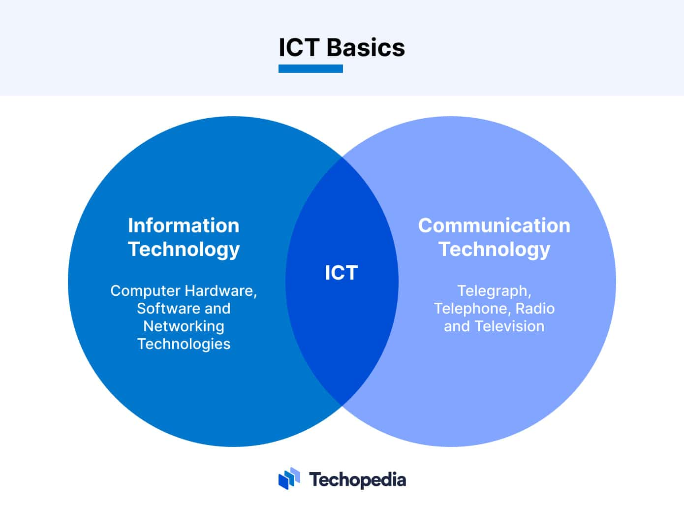

### **1.2 The Objective and Goal of Tic:**

### The **Goal** of Tic is to improve access to information and make human-to-human, human-to-machine, and machine-to-machine **(M2M)** communication easier and more efficient. Which in turn makes the *speed* of project development faster and more efficient compared to *basic methods* of **communication**.

### **2 History and Economy of Tic:**

### **2.1 The Development History of Tic:**

The concept of Tic can be traced back to the **19th century** . These two inventions **revolutionized** the way people worked and interacted socially by making it possible for one person to communicate with another person in a different location in *real* or *near-real time*.

In the middle of the **20th century**, **radio** and **television** introduced the concept of **mass communication**, and by the end of the century, **the Internet** had become a mainstream tool for **communication**.

| **Year** | **Technological Advancement** |
| --- | --- |
| **1837** | Morse code and telegraph |
| **1876** | Telephone |
| **1927** | Television |
| **1947** | Transistor |
| **1951** | First commercial computer |
| **1971** | First Email |
| **1990** | World Wide Web |
| **1994** | Netscape |
| **2001** | 3G |
| **2010** | 4G |
| **2020** | **5G and AI** |

### **2.2 The Economics of Tic:**

The money spent on IT worldwide has been estimated as **US$3.8 trillion** in 2017 and has been growing at less than **5%** per year since 2009.  
The estimated 2018 growth of the entire **TIC** is **5%**. The biggest growth of **16%** is expected in the area of new technologies

Here's a table that shows the Global IT industry market share (2020):

| **Country** | **Usa** | **East Asia** | **EU** | **South Asia** | **Latin America** | **Africa** | **Eastern Europe** | **Canada** |
| --- | --- | --- | --- | --- | --- | --- | --- | --- |
| **Percentage(%)** | 32% | 21% | 20% | 11% | 6% | 5% | 3% | 2% |

## **3 TIC As a subject in Education:**

**Tic** has also become **integral** to the **teaching-learning** interaction, through such approaches as replacing chalkboards with interactive digital white boards, using student’s own smartphones or other devices for learning during class time, and the **“flipped classroom”** model where students watch lectures at home on the computer and use classroom time for more interactive exercises.



### 

### **3.1 In developed countries**

**The Teaching of Tic** in developed countries *-most notably the USA-* has been a great success since the **2000's** and is only becoming more developed with time which shows that with effective education plans and enough funding ,it is *very* possible to make Tic a school subject for students lower than the level of university.

### **3.2 In 3rd world countries**

**efforts** to start implementing Tic in **universities** have been *fairly* successful, but its Implementation is not without its challenges.  
 *Even though* mobile phone and internet use are increasing much more *rapidly* in the third world, the progress is *still slow* but with enough **time** and **funding** it will be able to reach the level of success that developed countries have reached.



## **4 The Tech giants and important inventions of Tic:**

### **4.1 The Tech Giants:**

The Tech Giants are 5 Competitors in the domain of Tic and are considered the biggest and they are:

1. **Apple:** They are known for **Manufacturing** Phones, Tablets, Laptops, Earbuds..etc and Are also known for their Services including IOS , MacOS ,ITunes..etc.
2. **Amazon:** They are an e-commerce platform that sells many product lines,The company has multiple subsidiaries, including Amazon Web Services, providing cloud computing, Twitch, IMDb, and Whole Foods Market.
3. **Meta:** Meta are mosty known for creating the popular social media site **Facebook**, they recently acquired **instagram** in 2012 and are Currently investing in Virtual Reality.
4. **Google:** they are known for the **Google** search engine, online ads , e-commerce , Video sharing platform **Youtube** , **Ai** and much more…etc.
5. **Microsoft:** Their notable inventions are Windows os and the Office Suite that is a Software as a service (Saas).



### 

### 

### 

### 

### **4.2 Inventions:**

**4.2.1 Mobile phones:**

The main **competitors** in this domain are the american company **Apple** with the IOS operating system and Android based phone manufacturers like **Samsung**, **Huawei**, **Xiomi**,**Oppo.**..etc.

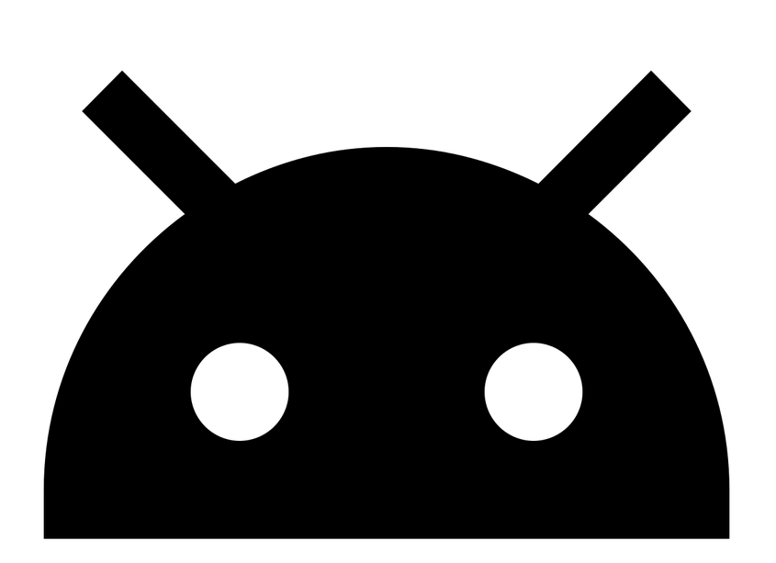

4.2.2 Computers:

Generally every computers in the world runs on one of these three operating systems:

1. **Windows OS**:Developed by **Microsoft**, it is the most popular operating system in the world and it is known for being the first **OS** to have Customer friendly UI.
2. **MAC OS**:Developed by **Apple**, it is known for being exclusive and only used by Apple laptops.
3. **Linux OS**: is a family of **Open-source** Unix-like operating systems based on the Linux kernel, its most popular distributions are: Mint, Ubuntu, ARK…etc.

## 

## 

## 

## **5 Modern day Challenges Associated with TIC:**

* **Digital divide:** There exists a grave digital divide in the world wherein gaps exist in the usage of the internet and access to digital infrastructure.
* **Privacy concern:** Recent advances in information technology threaten privacy and have reduced the amount of control over personal data and open up the possibility of a range of negative consequences as a result of access to personal data.
* **Cybersecurity threats:** With advancements in Tic, cybersecurity threats also continue to grow and evolve in frequency, vector, and complexity. The most common information security threats are malware attacks (eg. Ransomware).

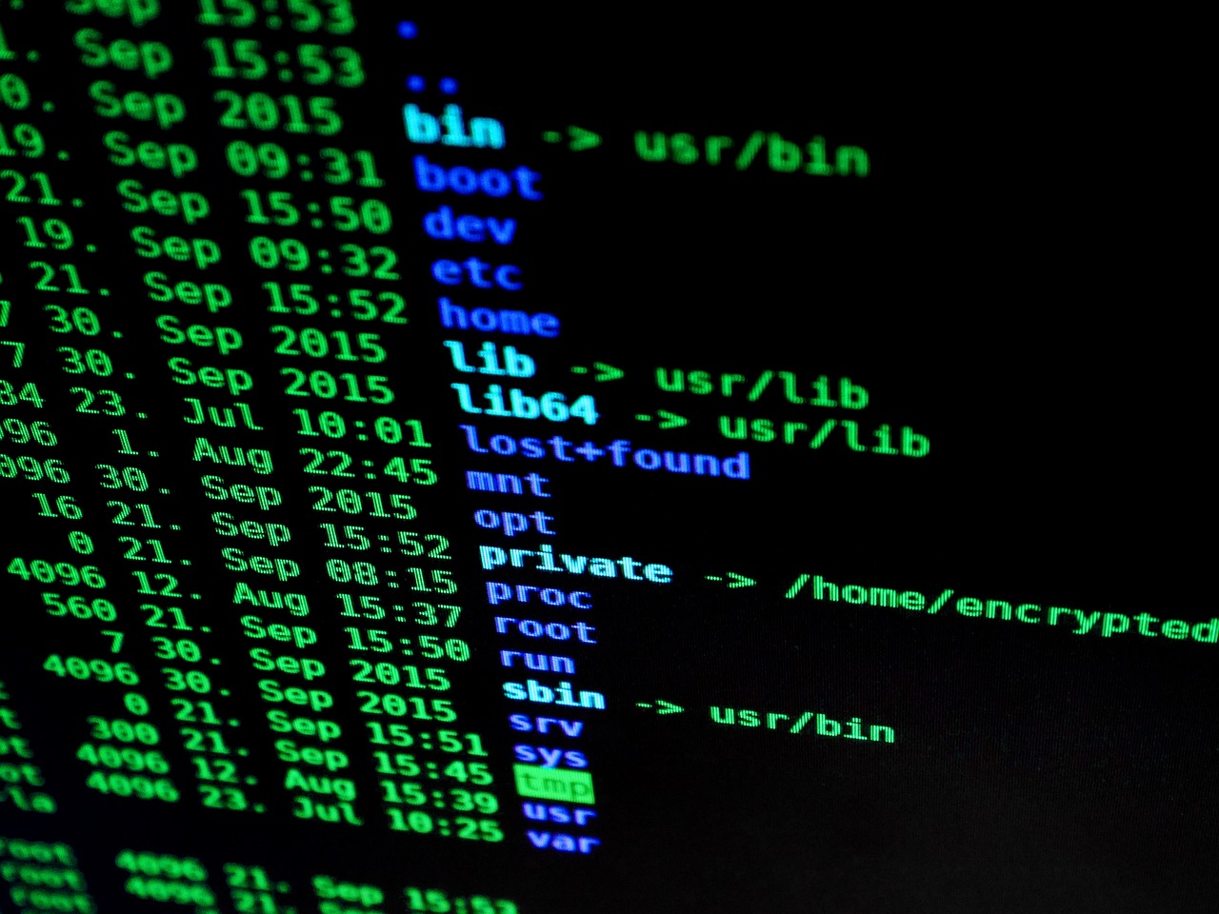

## 

## 

## **6 Modern day Applications of Tic**

* **Software Development:**Tic's main way of usage is developing software as it makes it more effecient to develop and design
* **Medecine:**The use of Tic has helped to develop new cures and treatments for illnesses. Most diseases are detected by computerized equipment refered as MRI, CT scanners, and ECG machines.
* **E-governance:**Tic can be utilized for government services, information exchange, communication transactions, and  
   integration of systems and services between government to citizens, and others
* **Defence:**Tic has transformed the defence industry from producing smart weapons to network-centric battlefield  
   management and from aftermath combat review to real-time combat surveillance.



## **7 Conclusion**

When we look at the history and its Economy in addition to The Main Areas of **Tic,** we can conclude that with Time the Domain of **Tic** is going to be more Advanced and going to have a *big* impact on **future technologies**,as world governments *support* it with more funds, *combat* it's challanges and *integrate* it into *education systems* and *hospital*..etc.

## **8 Sources**

[Technopedia](https://www.techopedia.com/definition/24152/information-and-communications-technology-ict)

[Wikipedia](https://en.wikipedia.org/wiki/Information_and_communications_technology)

[Aspire IAS](https://www.aspireias.com/currentaffairs/generatepdf/Information-and-Communication-Technology)

[Unesco](https://learningportal.iiep.unesco.org/en/issue-briefs/improve-learning/information-and-communication-technology-ict-in-education)

[StatAnalytica](https://statanalytica.com/blog/10-uses-of-ict-in-daily-life/)

[Comptia](https://www.comptia.org/content/research/it-industry-outlook-2020)